## Replication Set:-

Replica set is the next generation of Replication controller.

The replication controller only supports equality-based selectors where as the Replica set supports set based selector i.e. filtering according to the set f values.

Replica set rather than the Replication Controller is used by other objects like deployment.

Here we can used both equality based as well as set based selector.

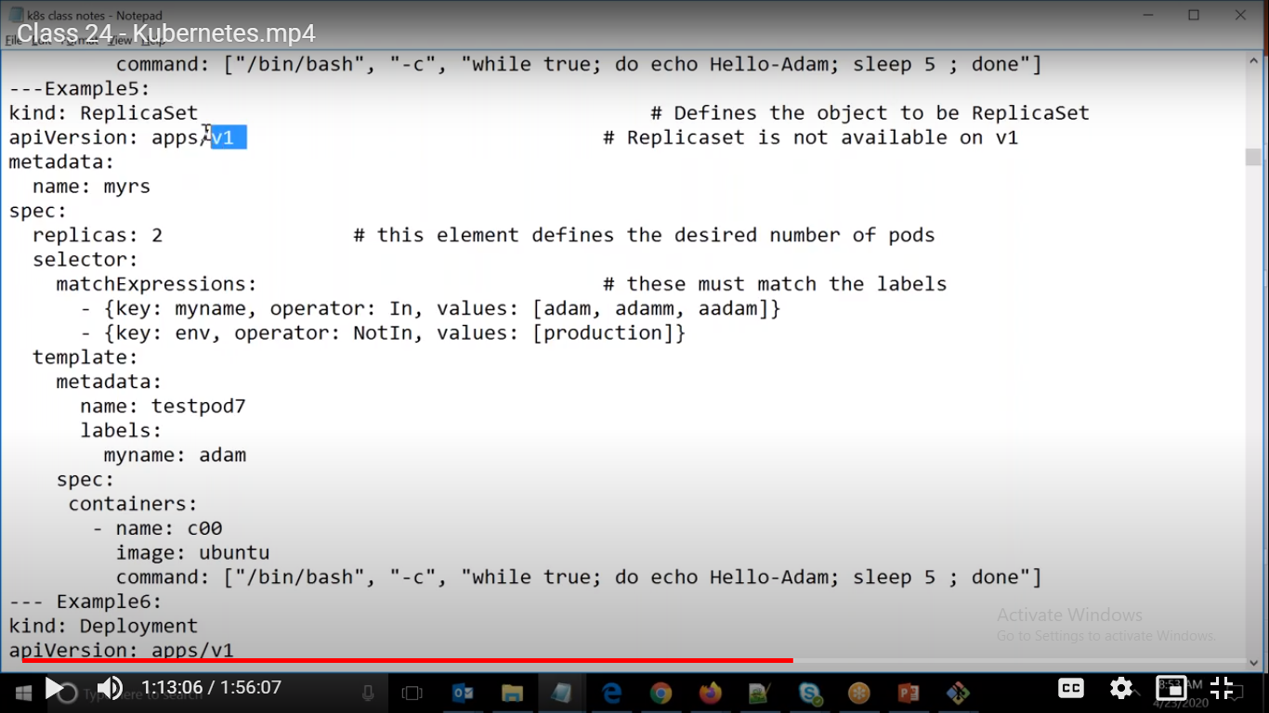

Here we can see that it is similar to Replication controller except

Kind: ReplicaSet

apiVersion: apps/v1

Here we are giving selectors based on set based.

matchExpressions -> Here key is myname and values should be anyone in adam,adamm, aadam

Similarly key is env and values should not be in production..

Command:-

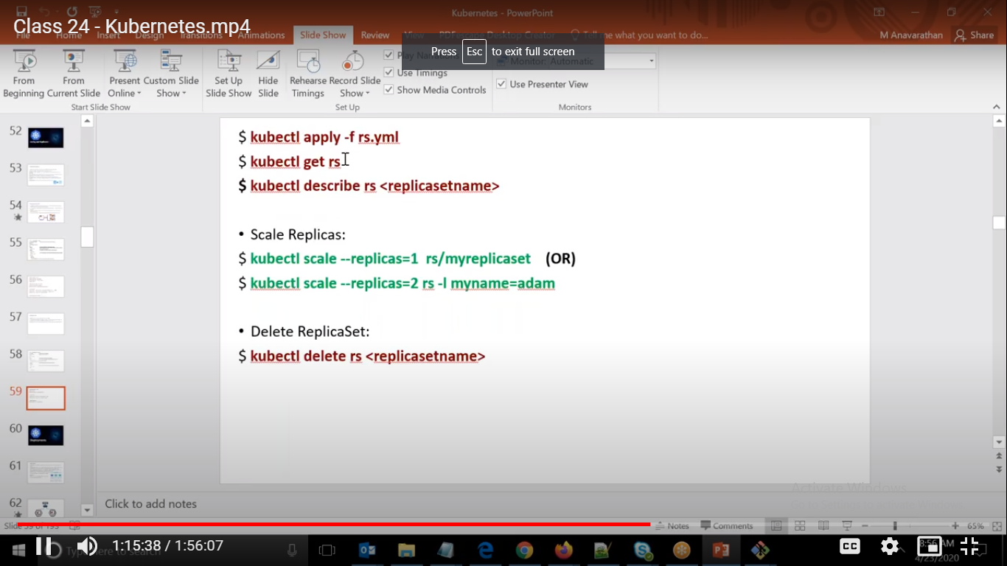

ubuntu@ip-172-31-41-23:~$ kubectl get rs

NAME DESIRED CURRENT READY AGE

myrs 2 2 2 66s

ubuntu@ip-172-31-41-23:~$ kubectl get pods

NAME READY STATUS RESTARTS AGE

myrs-szklc 1/1 Running 0 76s

myrs-x4hcc 1/1 Running 0 76s

ubuntu@ip-172-31-41-23:~$ kubectl describe rs

Name: myrs

Namespace: default

Selector: env notin (production),myname in (aadam,adam,adamm)

Labels: <none>

Annotations: Replicas: 2 current / 2 desired

Pods Status: 2 Running / 0 Waiting / 0 Succeeded / 0 Failed

Pod Template:

Labels: myname=adam

Containers:

c00:

Image: ubuntu

Port: <none>

Host Port: <none>

Command:

/bin/bash

-c

while true; do echo Hello-Adam; sleep 5 ; done

Environment: <none>

Mounts: <none>

Volumes: <none>

Events:

Type Reason Age From Message

---- ------ ---- ---- -------

Normal SuccessfulCreate 104s replicaset-controller Created pod: myrs-szklc

Normal SuccessfulCreate 104s replicaset-controller Created pod: myrs-x4hcc

ubuntu@ip-172-31-41-23:~$ kubectl delete pod myrs-szklc

pod "myrs-szklc" deleted

ubuntu@ip-172-31-41-23:~$ kubectl get pods

NAME READY STATUS RESTARTS AGE

myrs-58z9h 1/1 Running 0 20s

myrs-szklc 1/1 Terminating 0 2m31s

myrs-x4hcc 1/1 Running 0 2m31s

ubuntu@ip-172-31-41-23:~$ kubectl scale --replicas=3 rs/myrs

replicaset.apps/myrs scaled

ubuntu@ip-172-31-41-23:~$ kubectl get pods

NAME READY STATUS RESTARTS AGE

myrs-58z9h 1/1 Running 0 111s

myrs-9dh4x 1/1 Running 0 10s

myrs-x4hcc 1/1 Running 0 4m2s